Rotary Charity Sailing Flotilla B2B
Kornati islands, Croatia: 14th October – 16th October, 2023
Organizator: Rotary District 1913, Yachting Fellowship, RC Kaštela, YC Biograd

Route to Žut - 1. Biograd -Žut, 2. Sit around, 3.Žut Zminjak, 4.innersea Sustipanac Betina

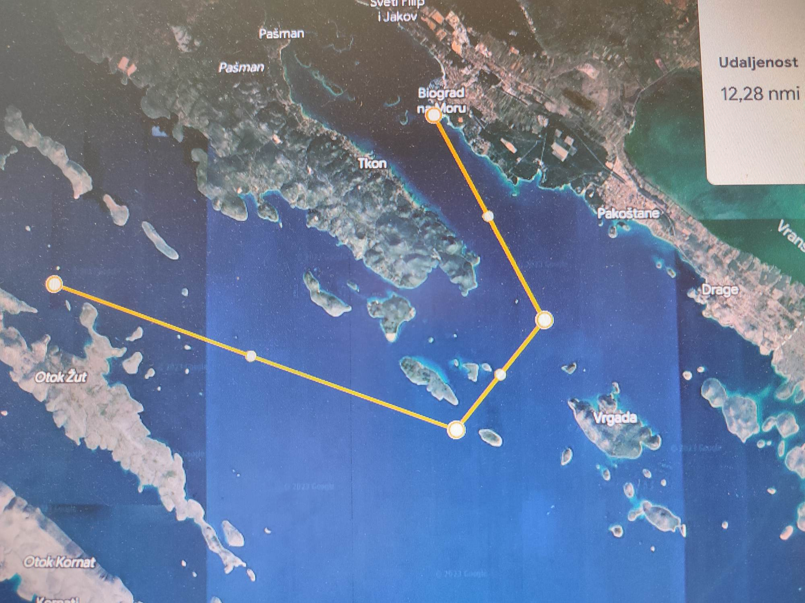
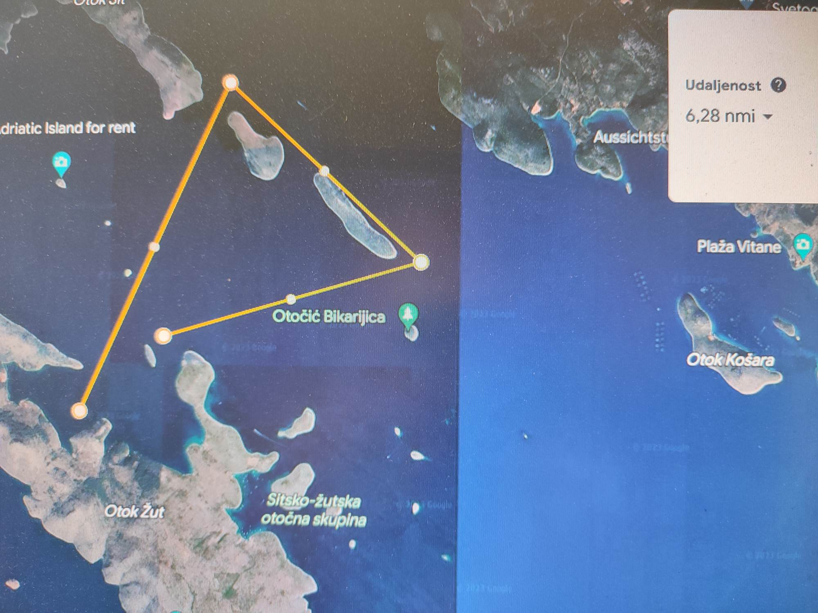
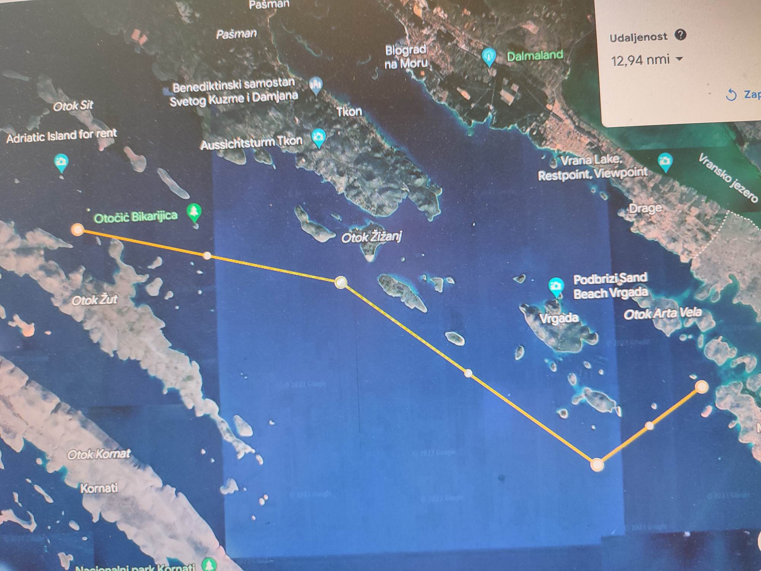
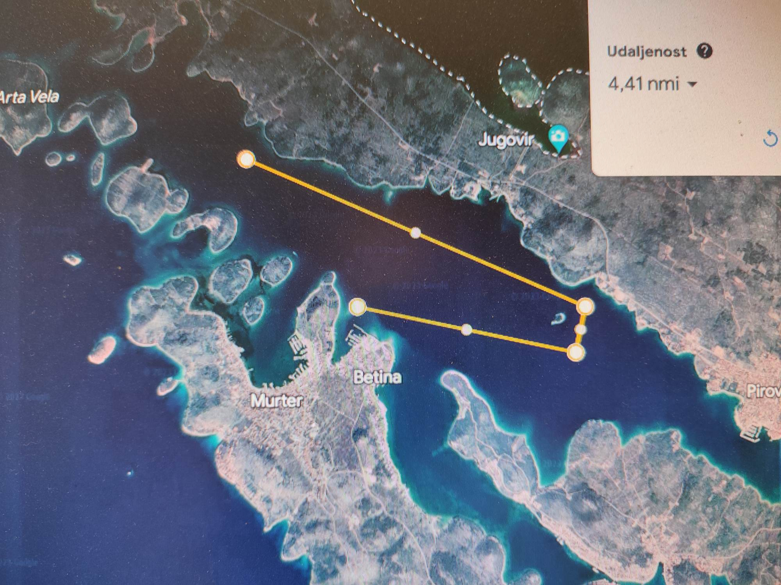

- The cost of a 3-day program is 154 €uro (190€ payment after September 01th, 01.09.) per person. Indication for payments of crew and persons in the Application. The price includes 3 dinners, music, organizational and regatta costs, cups and prizes, embroidery, humanitarian goal of the regatta. The cost of berth, meals on board and parking in the marina is not included in the price.
- Boat rental is not included, good prices through the organizers. Please make reservation before season to get better price and boat
- Payments to: on request before payment / Purpose of payment: Regatta registration fee
As a confirmation of the application for participation in the Regatta, each crew must pay the amount of € 50 per crew member, in case of cancellation they do not return, rest one month before regatta start

Honorary Committee: Sunčica Bulat Wursching District Govenor, PDG Ivan Miškulin, Fleet Commodore Boris Ninić, PDG Velibor Zolak PDG Danijel Jozić,
Race Committee: Gordan Borčilo, Boris Ninić, Dragan Pavelin,
Organizational committee: Gordan Borčilo, Vladimir Bulić, Dragan Pavelin, Zlatko Aljinović, Mario Radić-Filipović, Zoran Mikelić, Marko Čićin-Šain, Jozo Cikojević
Payment: Yacht Club BIOGRAD, 23210 Biograd, Ul. K.P. Svačića 17, p.p. 70, IBAN HR4324070001100568166 swift:OTPVHR2X
Information & registration:
Gordan Borčilo, sekretary IYFR Croatia ++385 98 273 088, info@rotary-yachting.com, www.IYFR-Croatia.com



